Project Documentation

# Introduction

Project name: Traffice Simulator

* What the software does, what it doesn't do? (this can be taken/updated from the project plan)

# Software structure

* Overall architecture, class relationships (diagram very strongly recommended), interfaces to external libraries

# Installation and user guide

## Installation guide

The instruction for download and install the software is described as the following. It can also be found in the README file in the software’s repository.

* Clone the software: git clone https://courses-git.comnet.aalto.fi/CPlusPlus/traffic-simulator-2019-1.git or download zip package and unzip.
* Create build directory inside of the project folder: mkdir build
* Open navigate into new “build” folder with terminal: cd build
* Generate makefile with CMake: cmake ..
* Build generated makefile: make
* Run it: ./a

## User guide

The user guide presents the basic instruction on how to use the application. The software includes three components in the main screen, which are the navigation bar, the action menus and the map. The application has two modes – editing and simulating. The guide structure is divided into two main parts based on the modes of the software.

The navigation bar is positioned on the top of the application. It contains three tabs – File, Mode, and Scale. File tab allows to save and load the map. There is one input area which requires users to insert a name for the file. Users have to remember the name of the save file for further loading. If the map is successfully saved or loaded. An information text will be shown in the Log table.

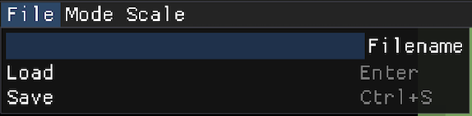

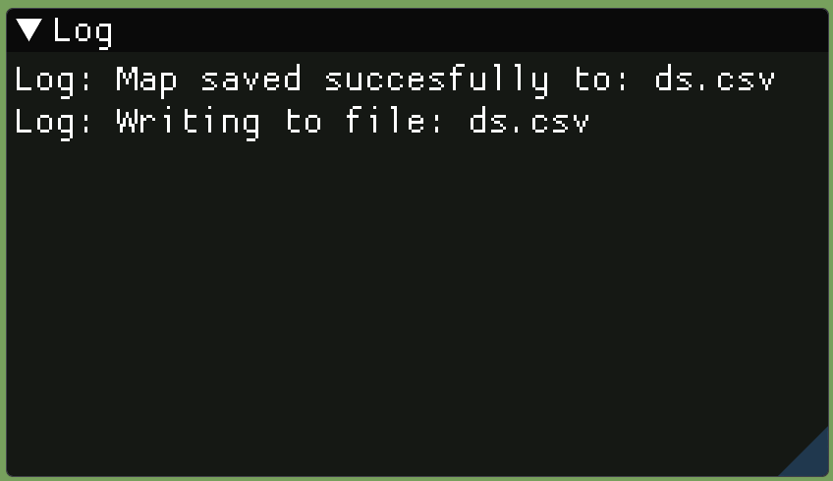

On the Mode tab, it is to change the mode of the application between editing and simulating modes. Editing mode allows users to building the map for simulation. After the map is ready, it is able to change to simulating mode to start to simulate the traffic. Scale tab is the place to change the font size of the text in the software. It depends on users’ screen resolution, a suitable scale number can be chosen.

### Editing mode

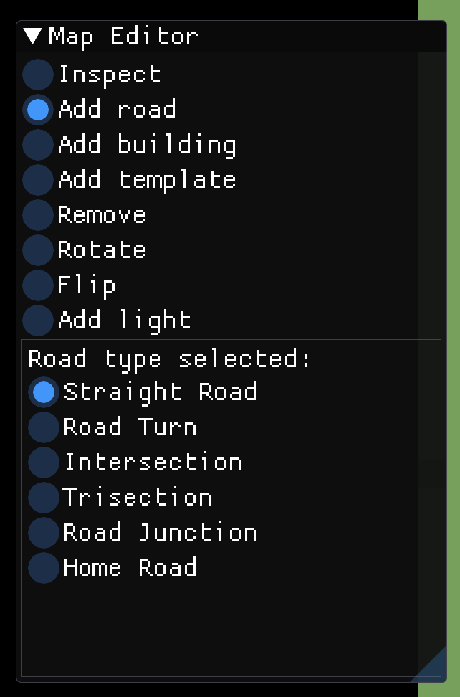By selecting Editing on the Mode tab, the screen is switched to editing mode. There is an action menu, named Map Editor, in which various building actions can be selected. The below table of the menu is the submenu, the contain is changed corresponding to the selected section on the top table. From the menu, users have many supported choices to build the city map.

* Inspect: it is to inspect the map. Pressing left mouse button is to move the map around, and mouse scroller to zoom in and out the map.
* 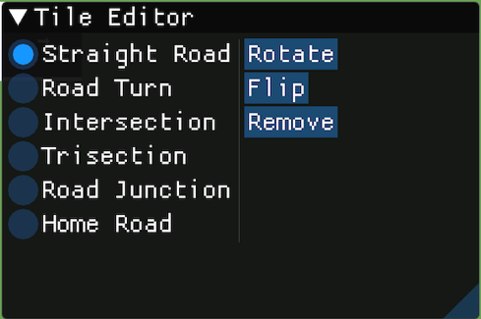Add road: it is to add various kind of road into the map. By selecting Add Road, users can see different kind of road in the sub menu. The road can be added by pressing the right mouse button on the desired places on the map. For quick build, it is recommended to press Ctrl and left mouse button. In order to change the type of the road and its direction, it is to click on the road tile, a popup menu appears, which is named Tile Editor. In the menu, users are allowed to switch between six type of roads, change its direction, and remove the road itself. In order to remove 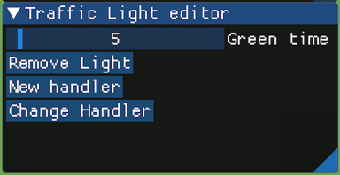multiple roads, users can hold the Shift button and left mouse button to remove the desired roads.
* Add building: there are two kind of buildings which are home and office building. The buildings should be added next to the road. If there is no building on the map, there is no cars in the simulation.
* Add template: the templates are some pre-building roads including cross intersection, T-intersection, and roundabout.
* Add light: the traffic light can be found in the section. After selecting Add light, pressing right mouse button will help to add traffic light to road. Traffic lights are managed in networks. If the traffic in a same traffic, there is only one green light at the same time. The setting for traffic light is in the popup menu named Traffic Light editor by clicking on the traffic light on the map. In the setting menu, users can edit the green time, add and remove the traffic light to a specific network.
* Rotate: it aims to assist road rotation. After selecting Rotate, using right mouse click to rotate roads.
* Flip: it is to flip roads by using right mouse button.
* Remove: using right mouse button to click on the road or building will remove it. It is suggested that holding Shift button and left mouse button for faster roads and building removal.

### Simulation mode

Simulation mode can be accessed by select Simulating in the Mode tab in the navigation bar. In this mode, users can see four popup menus.

* Time menu: it allows users to control the time in the software. It simulates the real-time of a day. In the below photo, the clock is the first line, which display the time in the application. The second line is the Time scale used to adjust of the speed of time. By changing the slider, the time speed can be slower or faster. The third line is the time which corresponds to the time in the first line. The time in the application can be controlled via this slider. The remaining buttons have different features. Reset Day to reset the time. Moring is used to set the time at 7:00 am. Afternoon adjusts the time to 3:00 pm. Hop 5, 15 and 60 mins to add that amount of time to the application’s time.

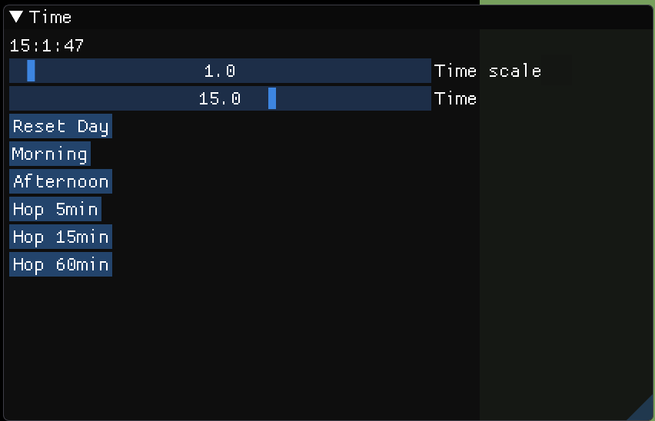

* Heat map: is a mini map which display the traffic heatmap. If the traffic gets heavy on specific road, the color of that road will change. In addition, it is able to navigate to the map via the mini map.

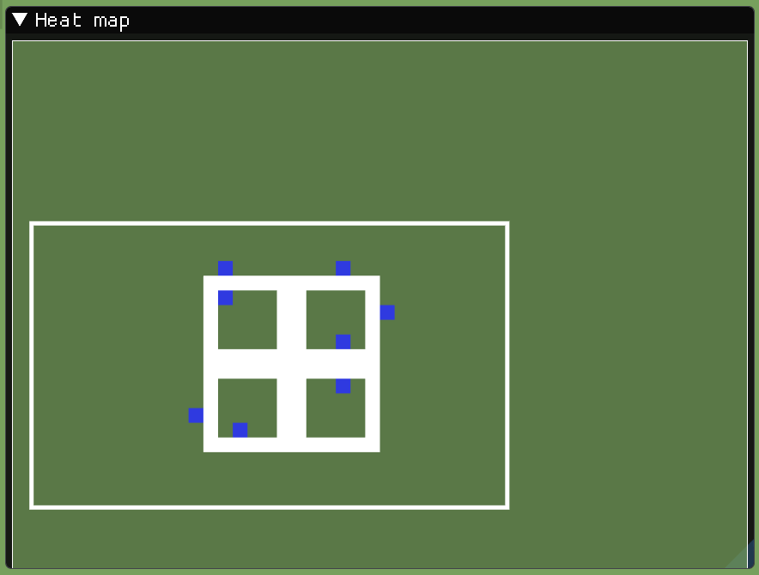

* Statistics: is the histogram representing the amounts of vehicles moving across the specific road for a day. There are 96 columns. Each column displays the amounts of vehicles for 15 minutes. The histogram can be interpreted that if there are 8 cars in columns number 30, it means that the amounts cars go through that road between 7:15 to 7:30 are 8. The statistics data can be exported to csv file by pressing on Export button. The file is saved under the name histogram.csv.

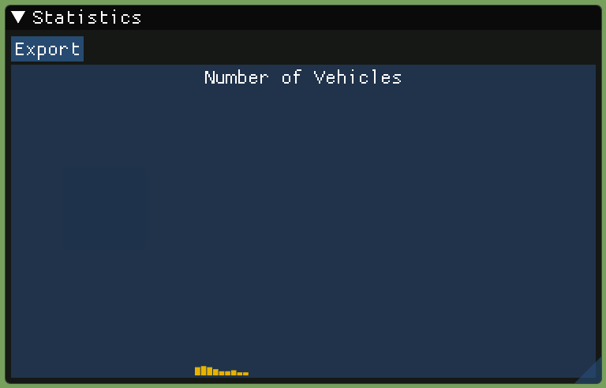

# Testing

* How the different modules in software were tested, description of the methods and outcomes

# Work log

* Detailed description of division of work and everyone's responsibilities
* For each week, description of what was done and roughly how many hours were used, for each project member